

Media Alert

Survey of 16 countries shows companies face increasing customer service challenges from lack of cross channel communications

Paris, April 28, 2010 – A new survey of consumers in 16 key countries finds that consumers are adopting multiple communication channels much faster than companies are ready to respond. The survey found that in 2009, over 90 percent of consumers have used multiple communication channels when contacting a company’s customer service.

Sponsored by Genesys from Alcatel Lucent and Ovum, a leading research company, the survey builds on data gathered in 2009 to determine the costs of poor customer service, to measure changes in consumer behavior, and to understand the challenges for enterprises in implementing customer service solutions to handle inquiries across communication channels.

“Less than 10 percent of companies are prepared today for cross channel conversations,” said Daniel Hong, Lead Analyst of Customer Interaction at Ovum. “The survey showed that customer frustration continues to grow as consumers attempt to contact companies using existing communication channels that do not transfer the context of the contact from one channel to another,” said Hong. “It’s imperative that an enterprise engage consumers on the customers’ terms or risk losing them.”

Most notable in the survey results is the desire for better human responses as the best way to improve communications that started through any one of a growing number of channels. These channels, while still dominated by voice, include texting (SMS), e-mail, live chat, Web self-service, and social media such as Twitter.

Cross channel communications occur when a consumer initiates a request or poses a query in one communication channel, and then continues that same conversation through multiple contact methods in order to reach a resolution. These cross channel communications have a significant impact on customer service expectations for consumers across all age groups, not just for those who are younger and more tech-savvy. A company that provides multiple ways for contact raises expectations that the service will be better – a more customer-friendly company.

A majority of consumers started on the Web and then went to a customer service representative (voice agent). This consumer behavior pattern is reflected in the large numbers indicating that the most satisfying channel of customer service was the phone and the highest priority for investment should be better trained human resources. This leads to the conclusion that consumers start customer service in a channel they find most convenient, but if issues arise or transactions are too complex, the best escalation is to a customer service representative who can consult and resolve the issue directly.

For example, the following figures show the reported paths of actual and desired cross channel conversations.

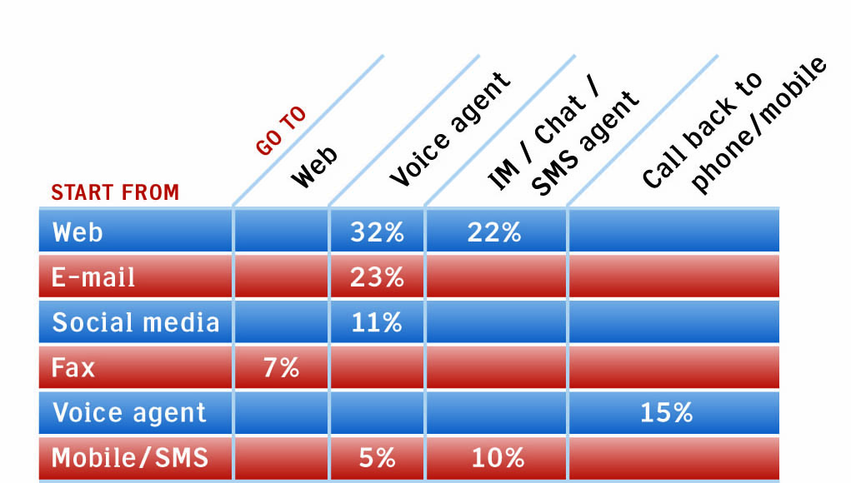

Survey Sample
A total of 8,880 consumers, at least 500 from each country, were selected from all age and income groups and surveyed for the report titled “The Cross Channel Customer Experience: Challenges, trends and gaps in customer expectations across 16 key economies.” Numerous questions were asked of consumers regarding which new communication channels they prefer to use when interacting with a company as well as what they think enterprises should be doing across multiple channels to address the pace of change in customer service.

Industries with the Best Customer Service
Consumers were also asked what industry provided the best customer service. No industry had a large lead in delivering cross channel conversations. However, the financial services industry has a leading position, followed by consumer product companies. While financial services rated the best, consumers did not identify any industry as doing an excellent job of delivering integrated cross channel conversations.

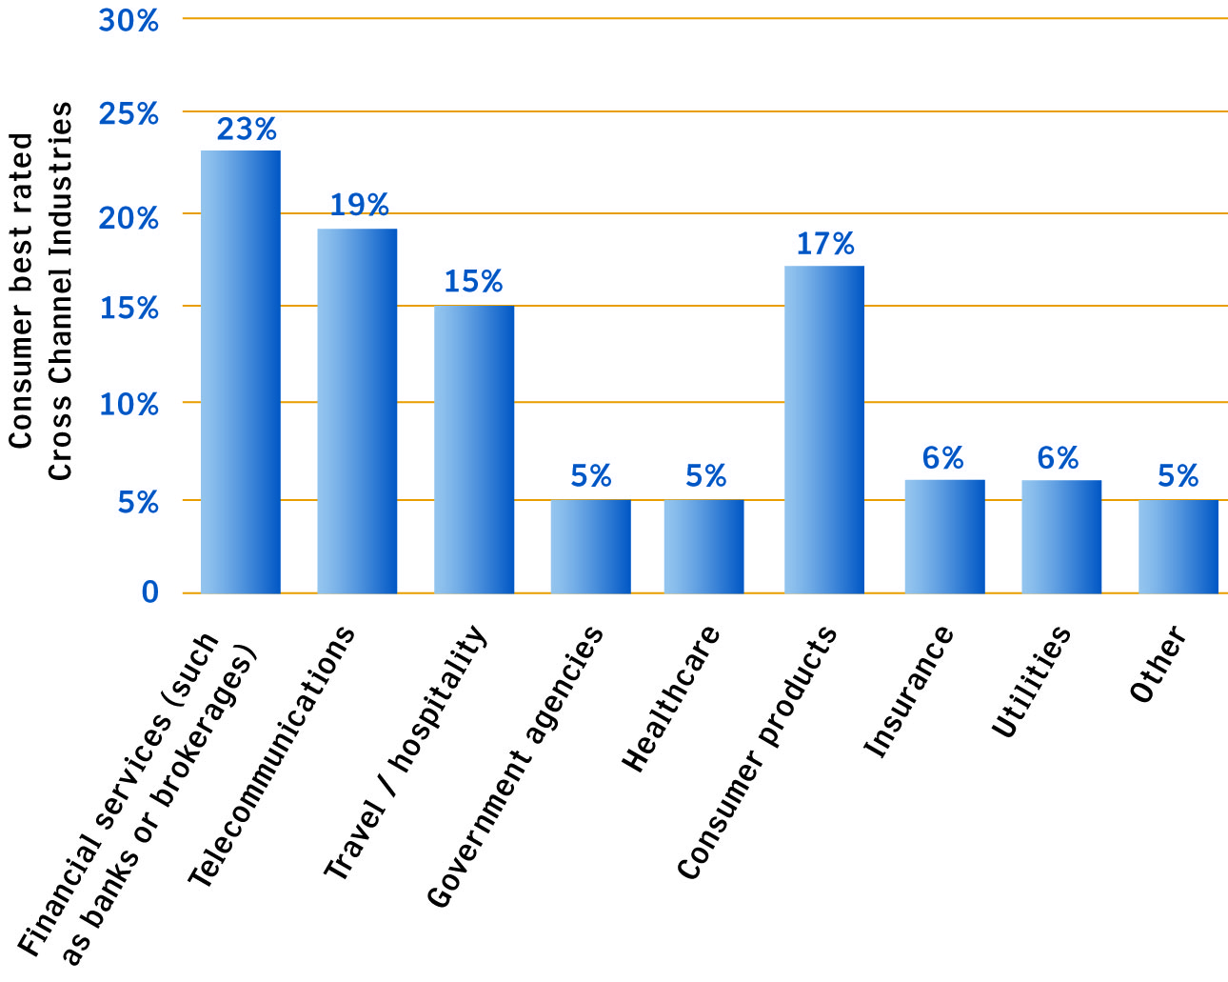

Best Communication Channels
Consumers’ preferred channels of interactions were primarily by phone, e-mail was a second choice while Web self-service was a distant third.

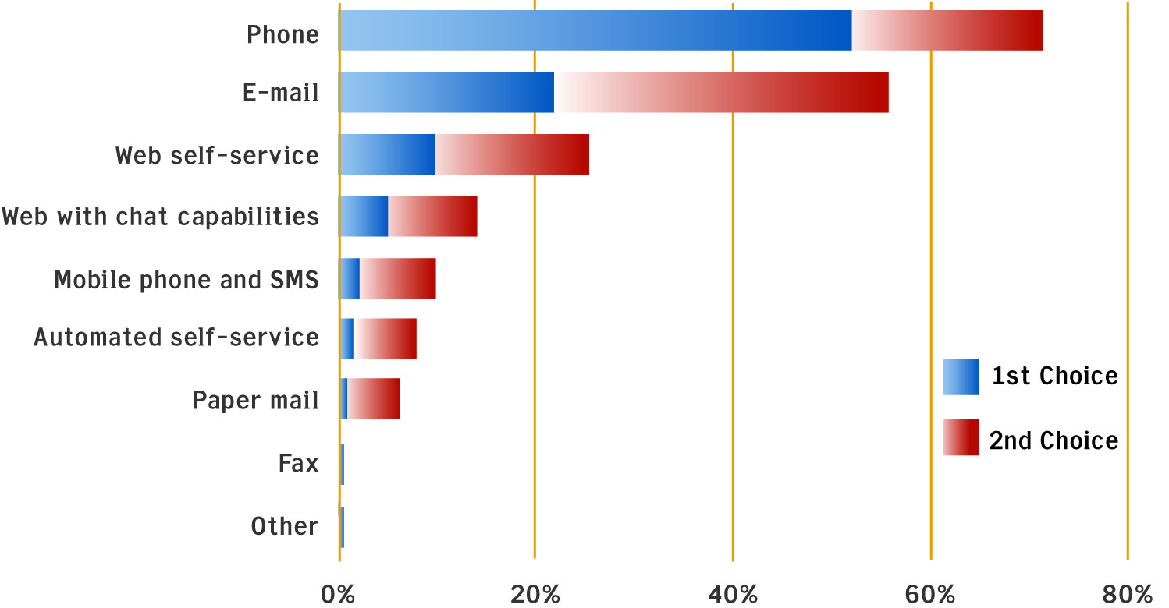

Common Wish Lists
There were common areas of agreement from across the regions and the various age groups. Consumers want to be able to start in self-service on the Web or via voice self-service and get live assistance from an agent, without having to re-enter information already provided. In other words, “Don’t ask me twice.” The leading suggestion on how to best improve cross channel conversations from 44 percent of the respondents was to provide “better human service,” which includes the agent already having the information provided via a different channel.

Most Requested Areas of Investment
When asked where organizations should invest more in customer service communication, consumers overwhelmingly asked for better integration of human contact center agents with other channels. They also wanted newer delivery methods, including avatars, social forums and multimedia.

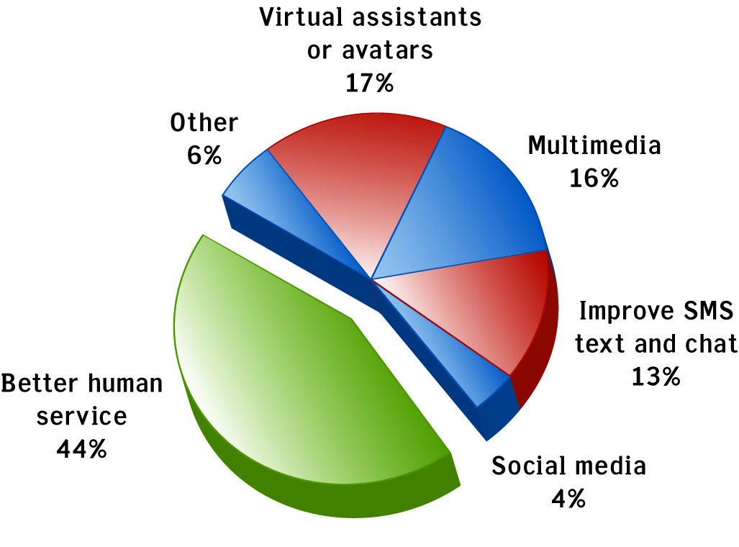

While many enterprises have accelerated their implementation of select, new communication channels, very few have tied them together into a complete system of customer care.

*Countries Surveyed
Countries included in the survey were:

Australia
Brazil
Canada
China
Czech Republic
France
Germany
India
Italy
Mexico
Netherlands
New Zealand
Poland
Russia
U.K.
U.S.

For a complete copy of “The Cross Channel Customer Experience: Challenges, trends and gaps in customer expectations across 16 key economies” survey, please send a request to press@genesyslab.com

About Genesys
Alcatel-Lucent’s Genesys solutions feature leading software that manages customer interactions over phone, Web and mobile devices. The Genesys software suite handles customer conversations across multiple channels and resources –self-service, assisted-service and proactive outreach – fulfilling customer requests and optimizing customer care goals while efficiently using resources. Genesys software directs more than 100 million customer interactions every day for 4,000 companies and government agencies in 80 countries. These companies and agencies leverage their entire organization, from the contact center to the back office, while dynamically engaging their customers. For more information, go to www.genesyslab.com.

About Alcatel-Lucent
Alcatel-Lucent (Euronext Paris and NYSE: ALU) is the trusted transformation partner of service providers, enterprises, strategic industries such as defense, energy, healthcare, transportation, and governments worldwide, providing solutions to deliver voice, data and video communication services to end-users. A leader in fixed, mobile and converged broadband networking, IP technologies, applications and services, Alcatel-Lucent leverages the unrivaled technical and scientific expertise of Bell Labs, one of the largest innovation powerhouses in the communications industry. With operations in more than 130 countries and the most experienced global services organization in the industry, Alcatel-Lucent is a local partner with a global reach. Alcatel-Lucent achieved revenues of Euro 15.2 billion in 2009 and is incorporated in France, with executive offices located in Paris. For more information, visit Alcatel-Lucent on the Internet: http://www.alcatel-lucent.com

Media Contacts:
David Radoff
Tel: + 1 650 466 1078
Email: dradoff@genesyslab.com

Duncan Burford
UK PR for Genesys
Tel: +44 (0)1780 721 433
Email: dburford@iba-international.com

