
Customer & Partner Quotes

“We know how unique we are, but in other areas we are similar to any other contact centre: we needed to optimise resources, reduce costs, and continually increase service levels — and we’re doing just that. Genesys has helped our volunteers to manage larger volumes of interactions and keep service levels high. We have seen a huge increase in the amount of Web contact since completing the project at the end of last year, and we expect that growth to continue. We are currently working with Genesys and ProtoCall One to add an SMS channel so that users can contact us via text message in the near future.”
Rosie Slater, IS Senior Business Partner, NSPCC

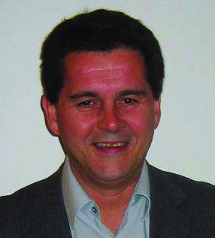
“We wanted a provider that could allow us to use various interaction channels efficiently — not deployed in silos — and we were convinced of Genesys after a visit to their Executive Business Centre in California. I came away with the opinion that Genesys is a leader among the pack and in the forefront of development. And I haven’t been disappointed. Our employees also see that Genesys makes their lives better, and they feel it is really a breakthrough compared to how they did things before.”
Per Ove Kristiansen, IT Manager – Channels, IT Customer and Distribution Solutions, DnB NOR

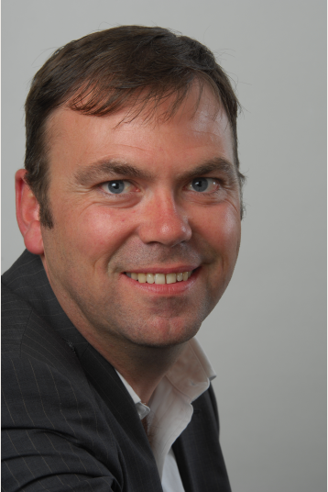
“C&W Worldwide is committed to providing the best mix of solutions for our customers, a sentiment that is echoed by Genesys. Genesys' suite of applications perfectly complement our mission critical communication solutions. We are jointly working towards an enhanced customer experience through the range and quality of our combined services. We have coupled Cable&Wireless Worldwide’s managed service approach, with Genesys’ focus on the delivery of customer service solutions. This result is that we can provide compelling propositions for businesses which enable customers to cut costs, drive multi-channel services and integrate front and back offices. The commitment shown by Genesys towards C&W Worldwide’s delivery of solutions is unrivalled.”
Philip Grannum, Managing Director, Enterprise at Cable&Wireless Worldwide

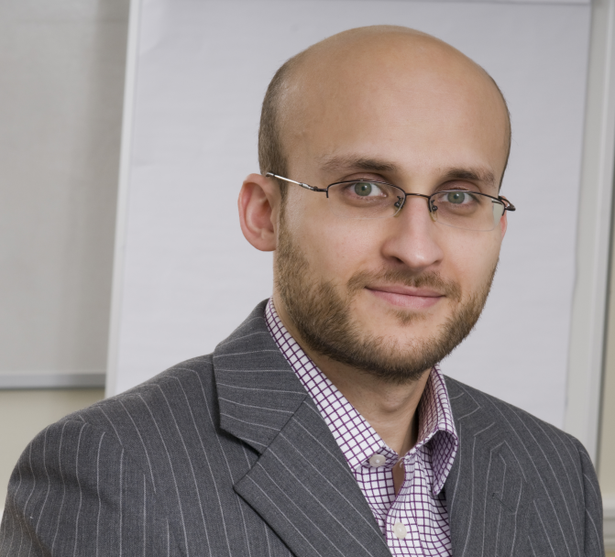
"G-Force is always an exciting event for us, it brings together the Genesys community and is a practical, hands-on forum. Everyone comes away from the event having learnt something that they can immediately apply in the field. We are delighted to have Rosie Slater from the NSPCC as a key speaker for the G-Force conference as Genesys and ProtoCall are proud of the joint solution we produced which really pushed the boundaries of multi-channel communications."
Faraz Khan, Managing Director, ProtoCall One


"Customer Service is no longer an activity for anyone. It demands competence and professionalism, especially since products become more complex and easy service tasks are handled via the web or automatic services. Customer Service nowadays is a strategic operation for adding value to products and services."
Lars O. Eriksson, Managing Director and Head of Vattenfall Customer Service Nordic

