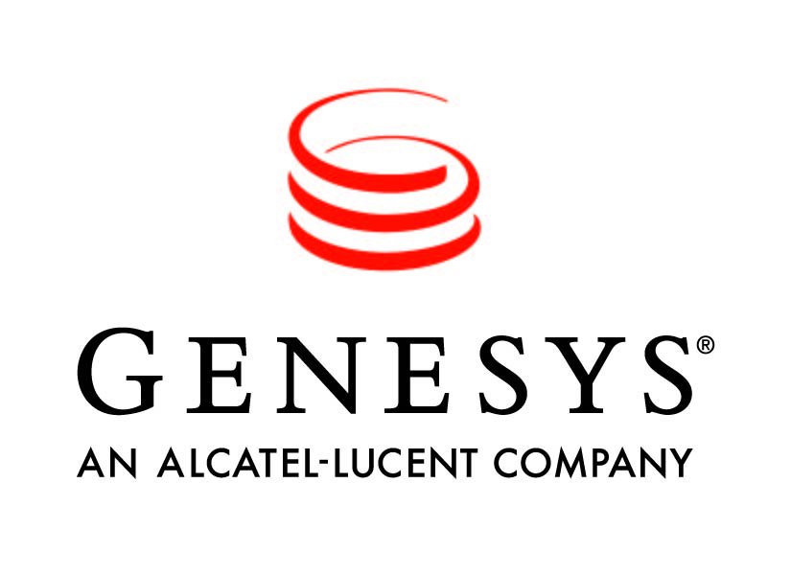


Corporate update: Alcatel-Lucent and Genesys

Alcatel-Lucent has brought together two of its solution portfolios – Genesys and the Enterprise – as part of a major effort to expand its Dynamic Enterprise vision and increase its market reach.
By bringing together the success of both its Genesys call centre activities and its Enterprise product lines, Alcatel-Lucent will deliver a powerful integrated suite of solutions that will feature an expanded set of offerings and broaden the company’s vision for the dynamic enterprise.
Alcatel-Lucent’s evolved dynamic enterprise vision provides leading enterprises with a path for building sustained strategic differentiation by interconnecting their networks, people, and processes and harnessing the connected knowledge of their customers, employees, and partners.
This new stage in the company’s dynamic enterprises approach brings a new method to enhance ‘collaboration’ with cross-channel ‘conversation’ – as well as enhancing employee and customer conversation management, over time and across any media, in a web 2.0 approach. This new approach augments employee interactions amongst themselves and between companies and their customers. Specific solutions will be unveiled later in the year.
This new approach also focuses on taking the enterprise communications platform, driving it to a more software-based architecture, and making it open to third party developers to create new mashed up services and applications.
About the Alcatel-Lucent new Dynamic Enterprise Vision:
The Alcatel-Lucent vision enables enterprises to focus on transforming the customer experience and driving innovation by engaging their workforce. The dynamic enterprise vision is built on two key strategies:

- Dynamic customer engagement – dynamic customer engagement is a strategy that proactively identifies and engages customers with the ideal service experience at the right time across any channel. It leverages the concept Genesys introduced of cross channel conversations that unify the various interactions a customer might have with an enterprise across time and channels – in-person, contact centre, web, smartphone and social media. Dynamic customer engagement leverages the entire enterprise, optimises customer service processes, and provides visibility into business performance.

- Dynamic employee engagement – dynamic employee engagement is a strategy that enables employees and partners to engage and innovate by bringing the concept of conversation to unified communication and collaboration to stimulate productivity. Conversation adds context, the right information and the ability to dynamically connect the workforce to make a difference in business situations. Key capabilities include rich presence to streamline business processes, instant communications using multiple media and disparate devices -- wired and mobile, at the office or on the road.

- Supporting these strategies is intelligent infrastructure – which provides networks with tools and capabilities to manage their growing complexity and expansion as bandwidth needs and the number of interconnected devices explode. It reduces operating costs and optimises the total cost of ownership. It is secure and open, and supports a wide range of models for deploying applications – on premise, hosted or a hybrid combination. The flexible deployment model enables companies to speed implementations at a lower level of capital investment.

- The organisational moves include merging the go-to-market forces of Genesys and Enterprise, merging the product creation capabilities and open software approach into the Application Software Group, and elevating the role of the Enterprise business. Taken together, these moves will significantly accelerate the development of innovative offers such as Unified Communications and IP telephony and the extension of the Genesys brand.

There are four key elements that make the Dynamic Enterprise vision unique to Alcatel-Lucent.

- Conversations will become the new collaboration paradigm. Fundamental to this vision is the notion that communications have undergone so much change that companies must take a completely new approach to conversations because they extend over time, across devices, and allow participants to join dynamically with an organisational memory of their content.

- User centricity means unifying the communication experience for knowledge workers across devices – wired and wireless, in the office and on the road – and for customers across communication channels.

- Open systems are critical because enterprises seek to maximise their existing investments.

- Hybrid cloud deployments deliver solutions that run on premises or in-cloud, or both, in a fluid manner to leverage the capabilities of the network and provide cost effective deployment options.

