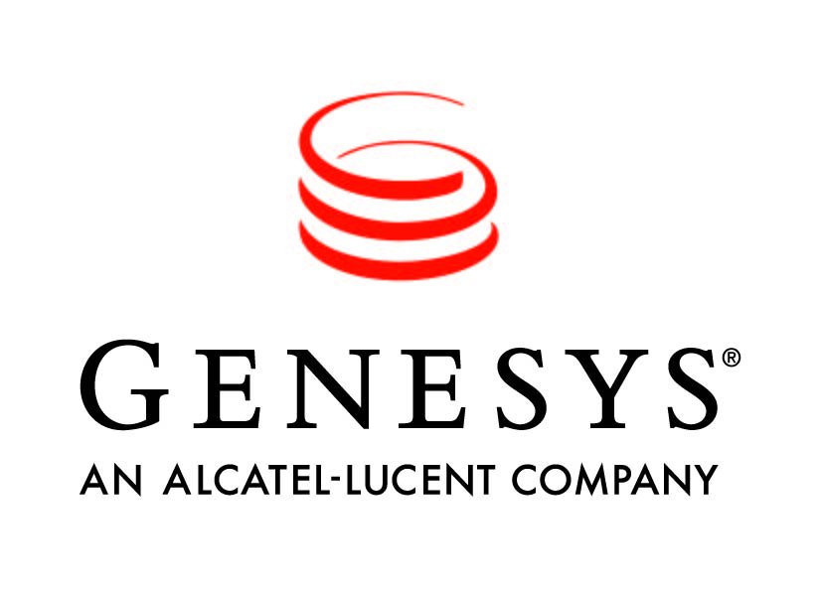



Product update: Genesys 8 Software Suite
The Genesys 8 software suite addresses critical enterprise needs by enabling a single, coordinated customer conversation across channels and contact points. Conversations made over multiple channels are now an improved customer experience through an integrated conversation and context manager that synchronizes conversations across multiple customer touch points – including in-person, contact centers, Web, mobile devices and social media.
Key Capabilities – Core Genesys 8 Platform
At the heart of Genesys 8 is a new integrated platform, interface and development environment that offers simplified administration and streamlined implementation. Organizations benefit from:
- Improved customer experience through an integrated conversation manager with embedded context manager that synchronizes conversations over time and across channels, in person, over the Web, mobile and social media
- Role-based interfaces that enable each enterprise user to design the customer experience, configure the software, engage with customers and optimize the customer service operation, depending on their role
- Flexibility through modular solutions for specific needs
The Genesys 8 platform and the administrative tools create a consistency that simplifies, unifies and orchestrates the customer experience for any size organization. This ties together all customer-service applications and leverages an open approach to technology and infrastructure, including telephony, CRM applications, unified communications, customer databases and other software. Genesys 8 also leverages industry standards, such as Session Initiation Protocol (SIP), a core standard for IP.
Modular solutions for the Genesys 8 Platform
Several new modular solutions work in concert with the core Genesys 8 platform or as standalone solutions. These modular solutions make it easier to implement the software beyond the contact center and in a variety of environments, including:
- Genesys Contact Center: This solution addresses traditional contact center agents by combining the Genesys platform, tailored role-based interfaces and tools.
- Genesys iWD (intelligent Workload Distribution): This solution uses rules and business processes to route tasks and work items to the most appropriate resource. Enterprises can ensure timely fulfillment of customer service requests by dynamically prioritizing and distributing tasks to those best suited to handle them. iWD distributes work based on the value of the task or the customer.
- Genesys Workforce Optimization: Workforce optimization enables enterprises to maximize efficiency through recording, speech analytics and quality management, workforce management, skills and training.
- Genesys iCFD (intelligent Customer Front Door): This integrated solution leverages the Conversation Manager with its embedded Context Services to collect customer intent and needs, determine how to treat them, and direct customers to the best resource.
- Genesys Performance Management: Includes complete reporting and analytics, leveraging the Advisor family and Interactive Insights applications for insight across all channels.
- Genesys eServices: The eServices solution brings together Web, mobile, and social media channels to support the contact center, marketing, social media, online-sales, and Web and back office agent organizations. It integrates knowledge and Web self-service with any Genesys voice, Web and mobile channel.

